DOWNLOAD MAVEN

<http://maven.apache.org/download.cgi>

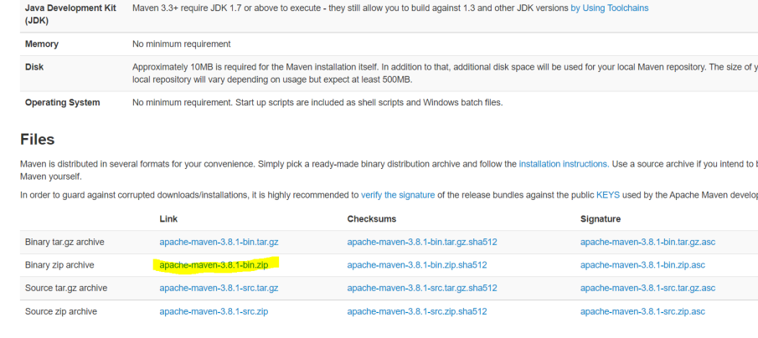

Unzip it to a folder. Eg: C:\apache-maven-3.8.1

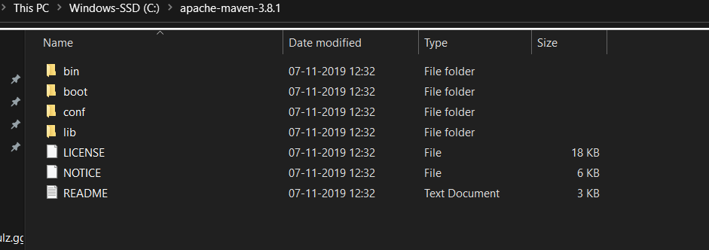

Add MAVEN_HOME system variable

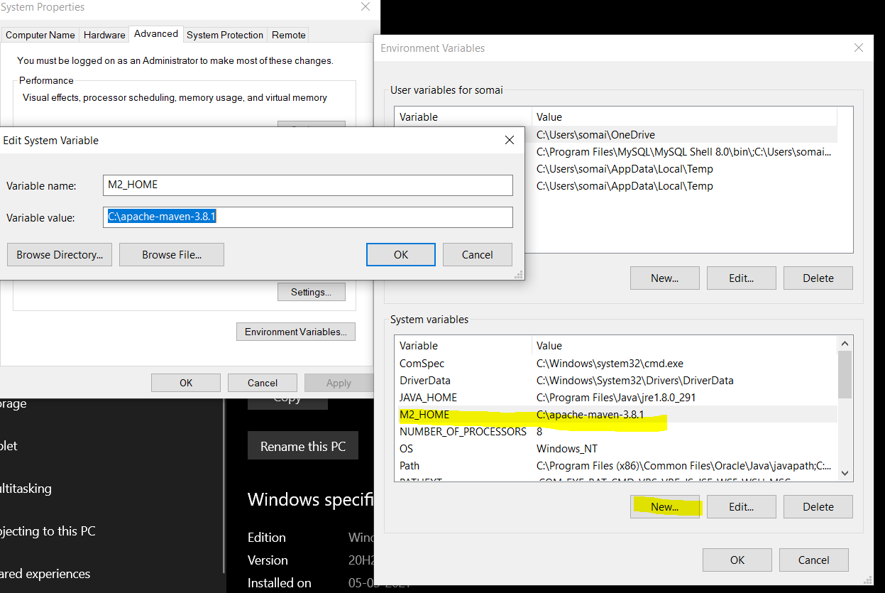

Add Maven bin to path variable

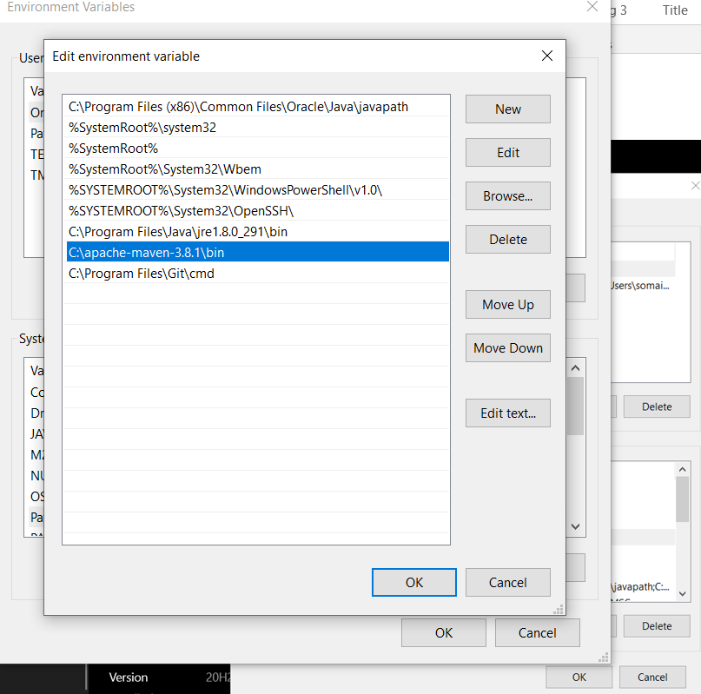

Verify Maven

Go to cmd prompt – type mvn -version

